V : .; .._ -..._!. .
,•' ,,
:"··\ ·' •/
tr : ., "" •
' 'v-,
. ·.;.it
1
i1·'kh
- :. '.
•.
\ t,'·:.ec,:,♦c- •
I

[
.•'J:.!
I·--

CHIEF OF POLICE MICHAEL A. MCDERMOTT

FEDERALSBURG
POLICE DEPARTMENT
P.O. Box 431
1 04 MORRIS AVE
FEDERALSBURG, MD 21632
PHONE #: (410) 754-8966 EMAIL: CHIEF@FEDERALSBURGPD.COM WEBSITE: FEDERALSBURGPOLICE.COM

'
"FOR SERVICE & SACRIFICE"

Press Release DT:01/13/2023

On January 11th, 2023 at 7:34 pm, Dominique Trane'ce Austin (32 of Laurel, DE) was stopped for a speeding violation on West Central Avenue at the intersection of Liberty Road in Federalsburg. Austin was operating a 2010 Dodge Charger and pulled over in the parking lot of the Lucky Corner Store. A K-9 Scan was conducted by SGT Adams and his partner, K-9 Mosley, and a positive alert to the presence of a Controlled Dangerous Substance was indicated. Austin was advised of the positive alert and instructed to exit her vehicle to allow for a further search.

Austin opened her driver door and SGT Adams, standing next to the door, moved to assist her. She then immediately closed her door and placed her manually operated Charger into reverse and accelerated. CPL Brannan of the FPD, who was assisting on the stop, was located directly behind the vehicle and had to jump out of the way to avoid being struck. SGT Adams grabbed the steering wheel to try and prevent Austin from running over CPL Branan. Austin then changed gears and accelerated rapidly forward with SGT Adams caught on the steering wheel. She stuck the side of CPL Brannan's marked police vehicle and momentarily stopped stating, "I'm ready to get out." Austin then reversed her direction and spinning the Charger recklessly in the parking lot and East Central Avenue all with SGT Adams locked onto the steering column. Austin then struck the side of CPL Brannan's vehicle a second time causing additional damage. She again accelerated rapidly circling the parking area before SGT Adams was slung off of the Charger and onto the pavement suffering injuries to his legs and ribs.

Austin traveled east on East Central Avenue at a high rate of speed and was pursued by CPL Brannan. During the chase, Austin exceeded 100 mph. The chase ended near the Delaware State Line where Austin was taken into custody and charged with multiple crimes and motor vehicle violations, including:
- 1st and 2nd Degree Assault/Assault on Law Enforcement Officer
- Reckless Endangerment
- Resisting Arrest/Obstructing and Hindering
- Fleeing and Eluding, and Reckless Driving, along with a host of other charges.

SGT Adams was transported by Caroline County EMS to University of MD Shore Medical Center in Easton where he was treated and released. CPL Brannan and K-9 Mosley avoided injury during the incident. The damage to the FPD Patrol vehicle is estimated at $7,000.00.

"FOR SERVICE & SACRIFICE"

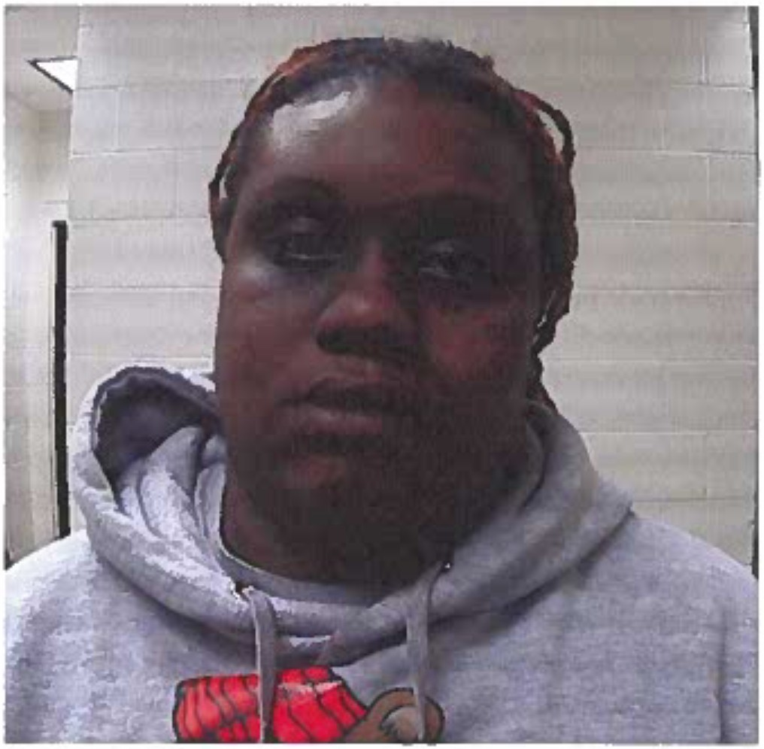
Domonique Trane'ce Austin 32 years old
1400 Grazing CT Laurel, Delaware

